PRACTICAL 3
Requirement Review, Inspection & Traceability Report
Login Module — Practice Test Automation
Application Under Review | Practice Test Automation — Test Login Page
Application URL | https://practicetestautomation.com/practice-test-login/
Module Reviewed | Login Module
Baseline Reviewed | Published requirement description on the Login page (functional text, credential rule, and the three worked test cases shown on the page)
Review Types Performed | Informal Requirement Review, Formal Inspection (IEEE 1028-style), Peer Review, Requirement Validation, Traceability Audit
SDLC Model | Agile Model — Static Testing phase, performed prior to test execution
Prepared By | QA Reviewer
Review Period | 02-Aug-2026 to 03-Aug-2026
Companion Artifact | Practical3_TestCases.xlsx (30 review test cases + Requirement Traceability Matrix)
Document Version | 1.0 — Final

1. Introduction
This report documents the Requirement Review and Formal Inspection performed on the published requirement description of the Login module of the Practice Test Automation demo application, ahead of test case design and execution. The activity follows standard static-testing practice: the requirement is examined for correctness, clarity, completeness, consistency, testability and traceability before any dynamic test is run against the application.
The review combined an informal Requirement Review, a Peer Review, a formal Inspection conducted against an IEEE 1028-style checklist, a Requirement Validation pass executed directly against the live application, and a Traceability Audit linking every requirement to its test evidence. Findings from all five activities are consolidated in this report and in the accompanying workbook, Practical3_TestCases.xlsx.

1.1 Objectives
- Confirm the Login module requirement description is complete, clear, consistent and testable.
- Formally inspect the requirement set for defects using a documented review checklist.
- Validate that each requirement statement matches the actual behaviour of the live application.
- Establish a Requirement Traceability Matrix (RTM) linking requirements to test cases and identify coverage gaps.
- Identify missing and ambiguous requirements, and define acceptance criteria for each reviewed item.

2. Scope
In scope: the requirement description published at https://practicetestautomation.com/practice-test-login/, covering the Login form controls, the single valid credential pair, the success redirect and confirmation message, the two negative error messages, and the three worked test cases documented on the page.
Out of scope: source code review (none was developed for this application; it is a third-party demo site), performance/load testing, and any requirement outside the Login page (e.g., sign-up, session management screens beyond the Log out button).

3. Reference Documents & Baseline
The requirement baseline reviewed in this report was extracted directly from the live Login page rather than from a separate SRS document, since the application publishes its own requirement text and worked examples in place of a formal specification. Eight baseline requirements (REQ_LOGIN_01 through REQ_LOGIN_08) were extracted. In addition, eight gap items (GAP_01–GAP_08) and two ambiguity items (AMB_01–AMB_02) were identified during review and are tracked alongside the baseline. The full baseline is listed in the “Requirement Baseline” sheet of Practical3_TestCases.xlsx.
Req ID | Requirement Statement (Summary)
REQ_LOGIN_01 | Login page presents Username, Password and Submit controls
REQ_LOGIN_02 | Authenticate only when Username='student' AND Password='Password123'
REQ_LOGIN_03 | Successful login redirects to a URL containing '/logged-in-successfully/'
REQ_LOGIN_04 | Post-login page shows 'Congratulations' or 'successfully logged in'
REQ_LOGIN_05 | Post-login page displays a 'Log out' button
REQ_LOGIN_06 | Invalid Username triggers 'Your username is invalid!'
REQ_LOGIN_07 | Invalid Password (valid Username) triggers 'Your password is invalid!'
REQ_LOGIN_08 | Error messages render on the same page; no redirect occurs

4. Review Methodology
Five complementary review activities were performed in sequence, consistent with static-testing practice taught for requirement reviews and inspections:
- Requirement Review (informal) — a walkthrough of each requirement against clarity, completeness and testability, performed individually per requirement.
- Peer Review — a second pass cross-checking the review findings for reviewer bias or oversight before formal inspection.
- Formal Inspection — a structured, checklist-driven defect hunt applied to the requirement set as a whole, evaluating the attributes Correctness, Unambiguous, Completeness, Consistency, Verifiability and Necessity.
- Requirement Validation — direct execution against the live application to confirm each requirement statement matches actual system behaviour, rather than relying on the written text alone.
- Traceability Audit — a forward and backward trace between every requirement/gap item and its test case(s), producing the RTM and a formal coverage gap analysis.
All five activities and every finding are captured as discrete rows in the “Review Test Cases” sheet of Practical3_TestCases.xlsx (30 rows, RTC_001–RTC_030), so each review activity in this report can be traced to a specific, auditable test case.

5. Requirement Review Checklist & Results
The checklist below reflects the informal Requirement Review pass (RTC_001–RTC_008), evaluating each baseline requirement individually.
Req ID | Clarity | Completeness | Testability | Result
REQ_LOGIN_01 | OK | OK | OK | Pass
REQ_LOGIN_02 | OK | OK | OK | Pass
REQ_LOGIN_03 | OK | OK | OK | Pass
REQ_LOGIN_04 | Ambiguous OR wording | OK | Partial | Fail
REQ_LOGIN_05 | OK | OK | OK | Pass
REQ_LOGIN_06 | OK | OK | OK | Pass
REQ_LOGIN_07 | OK | OK | OK | Pass
REQ_LOGIN_08 | OK | Inferred, not explicit | Partial | Fail

Result: 6 of 8 baseline requirements passed the Requirement Review outright; 2 were flagged for rewording and carried forward into the formal Inspection (see Section 6).

6. Requirement Inspection — Findings & Defect Log
The formal Inspection (RTC_009–RTC_014) applied six IEEE 1028-style quality attributes to the requirement set as a whole. Results per attribute:
Attribute | Checklist Item | Defects Found | Result
Correctness | Requirement matches observed system behaviour | 0 | Pass
Unambiguous | Exactly one interpretation per requirement | 1 (REQ_LOGIN_04) | Fail
Completeness | Trigger, outcome and page-state all stated | 1 (REQ_LOGIN_08) | Fail
Consistency | No requirement contradicts another | 0 | Pass
Verifiability | Objectively testable pass/fail | 0 | Pass
Necessity | No redundant or gold-plated requirement | 0 | Pass

Seven defects were logged during Inspection, Validation and Coverage Verification combined. The consolidated defect log is below; each defect references the review test case(s) that raised it.
Defect ID | Raised By | Requirement | Description | Severity | Status
DEF-INSP-01 | RTC_004, RTC_010 | REQ_LOGIN_04 | Success-message requirement uses an unresolved OR condition between two text fragments | Medium | Open
DEF-INSP-02 | RTC_008, RTC_011 | REQ_LOGIN_08 | Same-page/no-redirect behaviour on error is only inferable, not explicitly stated | Low | Open
DEF-INSP-03 | RTC_019, RTC_029 | REQ_LOGIN_04 | Live-page success text does not literally match either OR'd fragment on its own | Low | Open
DEF-INSP-04 | RTC_023, RTC_024 | REQ_LOGIN_08 | No existing test case explicitly asserts the URL is unchanged after an error | Low | Open
DEF-INSP-05 | RTC_026 | GAP_03, GAP_04, GAP_06, GAP_07 | Case-sensitivity, logout session effect, browser/device support and password masking are unspecified | Medium | Open
DEF-INSP-06 | RTC_027 | GAP_01, GAP_02 | No defined behaviour for simultaneous invalid fields or empty-field submission | Medium | Open
DEF-INSP-07 | RTC_028 | GAP_05, GAP_08 | No non-functional requirement for rate limiting, lockout, response time or transport security | Medium | Open

7. Requirement Validation Summary
Requirement Validation (RTC_015–RTC_019) executed each baseline requirement directly against the live application at https://practicetestautomation.com/practice-test-login/ to confirm the written requirement matches actual behaviour, rather than trusting the text in isolation.
Req ID | Validated Behaviour | Live Result | Match
REQ_LOGIN_02 | Only 'student' / 'Password123' authenticates | Confirmed on live page | Pass
REQ_LOGIN_03 | Redirect URL contains '/logged-in-successfully/' | Confirmed on live page | Pass
REQ_LOGIN_06 | Error text 'Your username is invalid!' | Confirmed verbatim | Pass
REQ_LOGIN_07 | Error text 'Your password is invalid!' | Confirmed verbatim | Pass
REQ_LOGIN_04 | Success message text | Live text reads 'Congratulations student. You successfully logged in!' — a superset of both OR'd fragments | Fail

Recommendation: update REQ_LOGIN_04 to the exact rendered string above rather than the current two-fragment OR condition, so the requirement and its acceptance criterion resolve to a single, unambiguous check (tracked as DEF-INSP-03).

8. Requirement Traceability Matrix (RTM) — Summary
The full RTM (16 rows covering 8 baseline requirements and 8 gap items) is maintained in the “RTM” sheet of Practical3_TestCases.xlsx. A condensed summary is presented here.
Req/Gap ID | Mapped Functional TC | Coverage Status
REQ_LOGIN_01 | TC_LOGIN_01 | Covered
REQ_LOGIN_02 | TC_LOGIN_01 | Covered
REQ_LOGIN_03 | TC_LOGIN_01 | Covered
REQ_LOGIN_04 | TC_LOGIN_01 | Covered (wording defect open)
REQ_LOGIN_05 | TC_LOGIN_01 | Covered
REQ_LOGIN_06 | TC_LOGIN_02 | Covered
REQ_LOGIN_07 | TC_LOGIN_03 | Covered
REQ_LOGIN_08 | None (implicit only) | Partially Covered
GAP_01 – GAP_08 (8 items) | None | Not Covered

16 | 7 | 9
Total Requirement/Gap Items | Fully Covered | Not / Partially Covered

9. Coverage Verification & Gap Analysis
Coverage Verification (RTC_024–RTC_026) audited the RTM in both directions:
- Forward audit — every baseline requirement checked for at least one mapped test case: 7 of 8 fully covered; REQ_LOGIN_08 only partially covered (DEF-INSP-04).
- Reverse audit — every existing functional test case (TC_LOGIN_01–03) checked for a traceable source requirement: 3 of 3 trace cleanly, with no orphan test cases.
- Gap audit — all 8 identified gap items checked against the existing test suite: 0 of 8 have any coverage, confirming they represent genuine, unaddressed requirement gaps rather than untraced existing tests.
Net result: baseline functional coverage is strong (87.5% fully covered, 12.5% partially covered), but 8 additional gap items remain entirely outside the current requirement baseline and therefore outside test scope until formally clarified.

10. Missing Requirements Identified
The following requirement gaps were identified during Inspection and Missing-Requirement Identification (RTC_027–RTC_028) and require stakeholder clarification before corresponding test cases can be designed:
Gap ID | Missing Requirement | Impact if Unaddressed
GAP_01 | Behaviour when Username and Password are both invalid | Ambiguous negative-test design; risk of testing an unspecified precedence rule
GAP_02 | Behaviour on empty-field submission | No defined pass/fail criterion for a common real-world negative path
GAP_03 | Case-sensitivity of credential comparison | Security-relevant behaviour left untested
GAP_04 | Session/URL effect of the Log out action | Logout correctness cannot be objectively verified beyond button presence
GAP_05 | Rate limiting / lockout / CAPTCHA after repeated failures | Brute-force exposure cannot be assessed or tested
GAP_06 | Supported browsers, devices, responsive behaviour | Cross-browser/responsive defects may go undetected
GAP_07 | Password field masking | Basic confidentiality expectation left unstated and untested
GAP_08 | Response time, availability, transport security (HTTPS) | No non-functional acceptance bar exists for this page

11. Ambiguous Requirements Identified
Amb. ID | Requirement | Ambiguity | Recommended Resolution
AMB_01 | REQ_LOGIN_04 | OR-worded success message ('Congratulations' or 'successfully logged in') without a governing rule for evaluation | Replace with the exact live-page string: 'Congratulations student. You successfully logged in!'
AMB_02 | REQ_LOGIN_02 | Silent on whether credential check is client-side or backend, affecting negative/security test scope | Log as an open question; proceed with black-box testing, escalate before security test design

12. Acceptance Criteria
Acceptance criteria were defined or confirmed for each baseline requirement as part of the review, in Given/When/Then form, to remove ambiguity before test design.
Req ID | Acceptance Criteria
REQ_LOGIN_01 | Given the Login page is opened, when it finishes loading, then a Username field, a Password field and a Submit button are all visible and enabled.
REQ_LOGIN_02 | Given the Login page is open, when Username='student' and Password='Password123' are submitted, then authentication succeeds; any other combination is rejected.
REQ_LOGIN_03 | Given valid credentials are submitted, when the page reloads, then the new page URL contains 'practicetestautomation.com/logged-in-successfully/'.
REQ_LOGIN_04 (revised) | Given valid credentials are submitted, when the success page loads, then it displays the exact text 'Congratulations student. You successfully logged in!'.
REQ_LOGIN_05 | Given a successful login, when the success page loads, then a 'Log out' button is visible and enabled.
REQ_LOGIN_06 | Given an incorrect Username is submitted, when Submit is pressed, then the exact text 'Your username is invalid!' is displayed and the URL does not change.
REQ_LOGIN_07 | Given a correct Username with an incorrect Password, when Submit is pressed, then the exact text 'Your password is invalid!' is displayed and the URL does not change.
REQ_LOGIN_08 (revised) | Given any invalid-credential submission, when the error message is displayed, then the page URL is asserted to be unchanged from the Login page URL.

13. Screenshot Evidence
The placeholders below mark where review evidence screenshots should be inserted prior to sign-off. Each corresponds to a specific review or validation test case in Practical3_TestCases.xlsx.
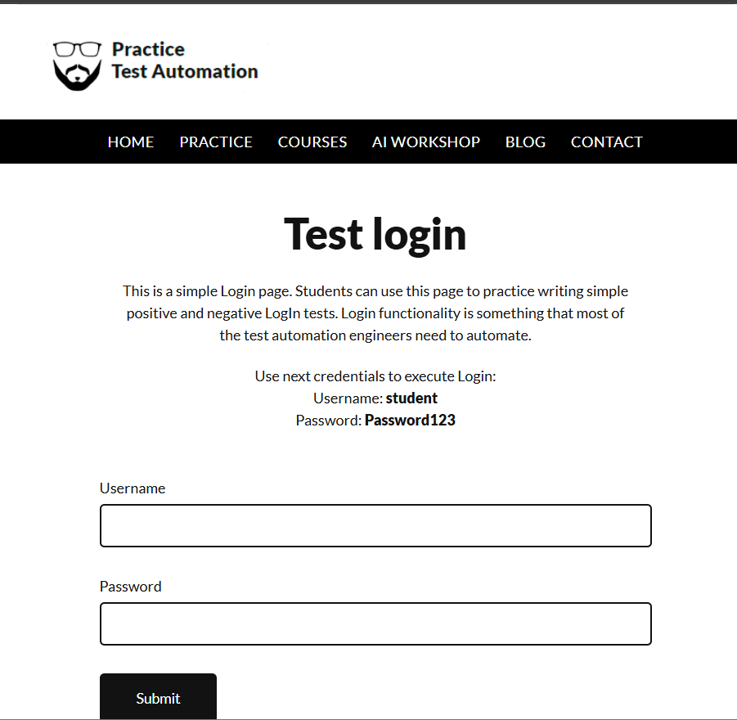

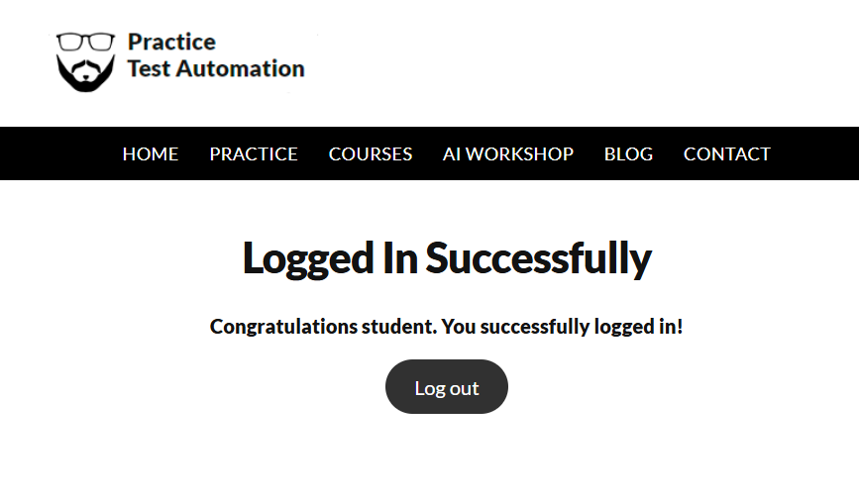

Invalid Username Error
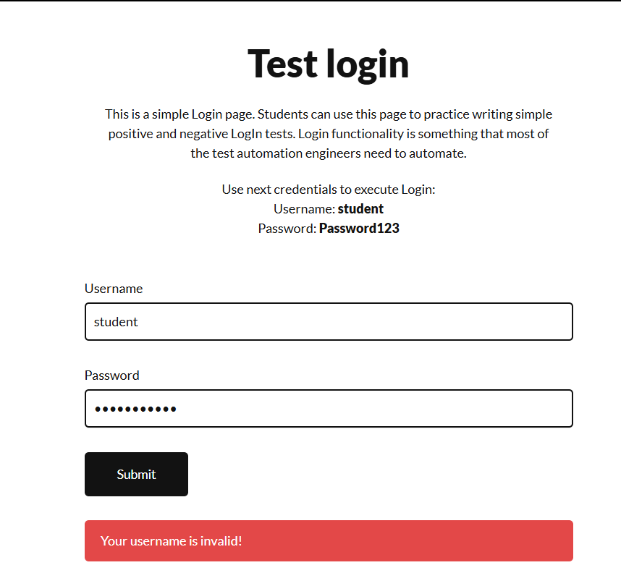

Invalid Password Error
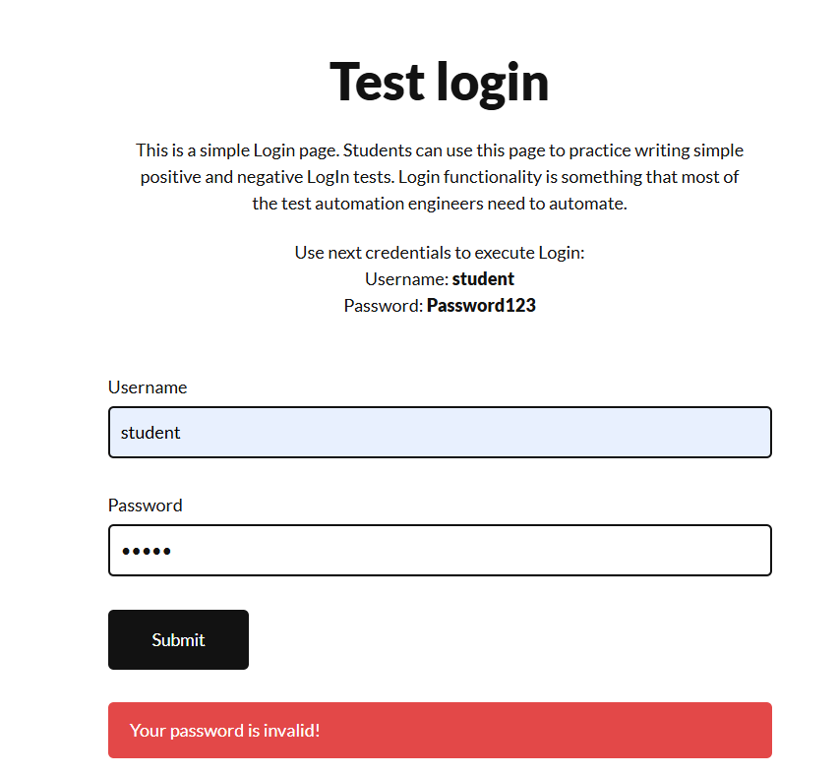

[ SCREENSHOT PLACEHOLDER — Inspection Checklist Working Copy ]

14. Observations
- The three functional requirements that are documented (positive login, invalid username, invalid password) are precise, testable and fully validated against the live application.
- Both defects raised against REQ_LOGIN_04 and REQ_LOGIN_08 are wording/completeness issues rather than functional defects in the application itself — the application behaves consistently; the requirement text needs tightening.
- No requirement in the baseline addresses non-functional behaviour (security, performance, accessibility, responsiveness); this is the most significant coverage risk identified during this review.
- Existing functional test cases (TC_LOGIN_01–03) trace cleanly to the baseline with no orphan tests, indicating a sound original three-test suite for the requirements it actually addresses.

15. Recommendations
- Reword REQ_LOGIN_04 to the single, exact success-message string confirmed during Requirement Validation (DEF-INSP-01, DEF-INSP-03).
- Add an explicit 'no redirect / same-page' statement to REQ_LOGIN_08, and extend TC_LOGIN_02/03 with an explicit URL-unchanged assertion (DEF-INSP-02, DEF-INSP-04).
- Raise formal requirement change requests for GAP_01–GAP_08 and route non-functional items (GAP_05, GAP_08) to security/performance stakeholders (DEF-INSP-05, DEF-INSP-06, DEF-INSP-07).
- Re-run the Requirement Inspection once the requirement baseline is updated, to confirm all seven open defects are closed before the next test-execution cycle.
- Capture the screenshot evidence identified in Section 13 and attach it to this report before final sign-off.

16. Conclusion
The Login module requirement baseline is fundamentally sound: all eight documented requirements are correct, consistent, verifiable and necessary, and the three existing functional test cases trace to it without gaps or orphans. Formal Inspection nonetheless identified two wording/completeness defects within the documented baseline, and Coverage Verification surfaced eight requirement gaps — chiefly non-functional — that fall entirely outside the current baseline. None of the seven open defects blocks execution of the three existing functional test cases; all seven should, however, be resolved with the product owner before the requirement baseline is considered final and before any additional negative or non-functional test cases are designed against it.

17. Review Sign-off
Role | Name | Signature | Date
Reviewer / Tester
Peer Reviewer
QA Lead / Approver

— End of Report —

